Joel Atkinson
January 30, 2026
CSD430 Server Side Development
Assignment 4.2
JavaBean Code:
package beans;
import java.io.Serializable;
import java.util.ArrayList;
/* Joel Atkinson, January 30, 2026, CSD430 Assignment 4.2 JavaBean
The purpose of this assignment is to create a JavaBean to hold the data from assignment 2.2 and then write
a JSP page to display the data. This is the JavaBean file for the assignment where the data is stored and then will be
retrieved and displayed using the JSP page */
public class FavoriteCitiesBean implements Serializable {
private static final long serialVersionUID = 1L;
private ArrayList<String[]> places;
// No-argument constructor
public FavoriteCitiesBean() {
places = new ArrayList<>();
places.add(new String[]{"Munich", "Germany", "2023", "Drank beer at Oktoberfest"});
places.add(new String[]{"Hallstatt", "Austria", "2023", "Explored the beautiful town"});
places.add(new String[]{"Honolulu", "USA", "2022", "Visited Pearl Harbor"});
places.add(new String[]{"Houston", "USA", "2018", "Attended the Houston Rodeo"});
places.add(new String[]{"Rome", "Italy", "2023", "Drank wine across from the Colosseum"});
places.add(new String[]{"Niagara Falls", "Canada", "2020", "Took the Maid of the Mist"});
places.add(new String[]{"Positano", "Italy", "2023", "Boat tour along the Amalfi Coast"});
places.add(new String[]{"Banff", "Canada", "2020", "Horseback riding through the Rocky Mountains"});
places.add(new String[]{"Orlando", "USA", "2025", "Took my daughter to Disney World"});
}
// Getter
public ArrayList<String[]> getPlaces() {
return places;
}
// Setter
public void setPlaces(ArrayList<String[]> places) {
this.places = places;
}
}

JSP Code:
<%--
Joel Atkinson, January 30, 2026, CSD430 Assignment 4.2
The purpose of this assignment is to create a JavaBean to hold the data from assignment 2.2 and then write
a JSP page to display the data. This is the JSP file for the assignment where it will pull the data from the JavaBean
and display it
--%>
<%@ page language="java" contentType="text/html; charset=UTF-8"
pageEncoding="UTF-8"%>
<%@ page import="beans.FavoriteCitiesBean" %>
<%@ page import="java.util.ArrayList" %>
<!DOCTYPE html>
<html>
<head>
<title>My Favorite Cities I Have Visited</title>
<link rel="stylesheet" href="assignment_2_2.css">
</head>
<body>
<div class="header">
<h1>My Favorite Cities in the World that I Have Visited</h1>
<%-- Adding in paragraph to show that the information is retrieved from a Javabean to change the display slightly
from assignment 2.2 which displayed the same information --%>
<p>
This page displays data retrieved from a JavaBean.
The JavaBean stores information about cities I have visited,
including location, year visited, and favorite activities.
</p>
</div>
<hr class="gold-divider">
<%
// Create JavaBean instance
FavoriteCitiesBean cityBean = new FavoriteCitiesBean();
// Retrieve data from the JavaBean
ArrayList<String[]> places = cityBean.getPlaces();
%>
<div class="content">
<h2>Favorite Cities Table (9 Records)</h2>
<table>
<tr>
<th>City</th>
<th>Country</th>
<th>Year Visited</th>
<th>Favorite Thing I Did While There</th>
</tr>
<%
for (String[] place : places) {
%>
<tr>
<td><%= place[0] %></td>
<td><%= place[1] %></td>
<td><%= place[2] %></td>
<td><%= place[3] %></td>
</tr>
<%
}
%>
</table>
<h3>Field Descriptions</h3>
<ul>
<li><strong>City:</strong> The city or location visited</li>
<li><strong>Country:</strong> Country where the city is located</li>
<li><strong>Year Visited:</strong> Year the visit occurred</li>
<li><strong>Favorite Thing:</strong> Memorable activity during the visit</li>
</ul>
</div>
</body>
</html>

Screenshot of JSP file running and connected to server:
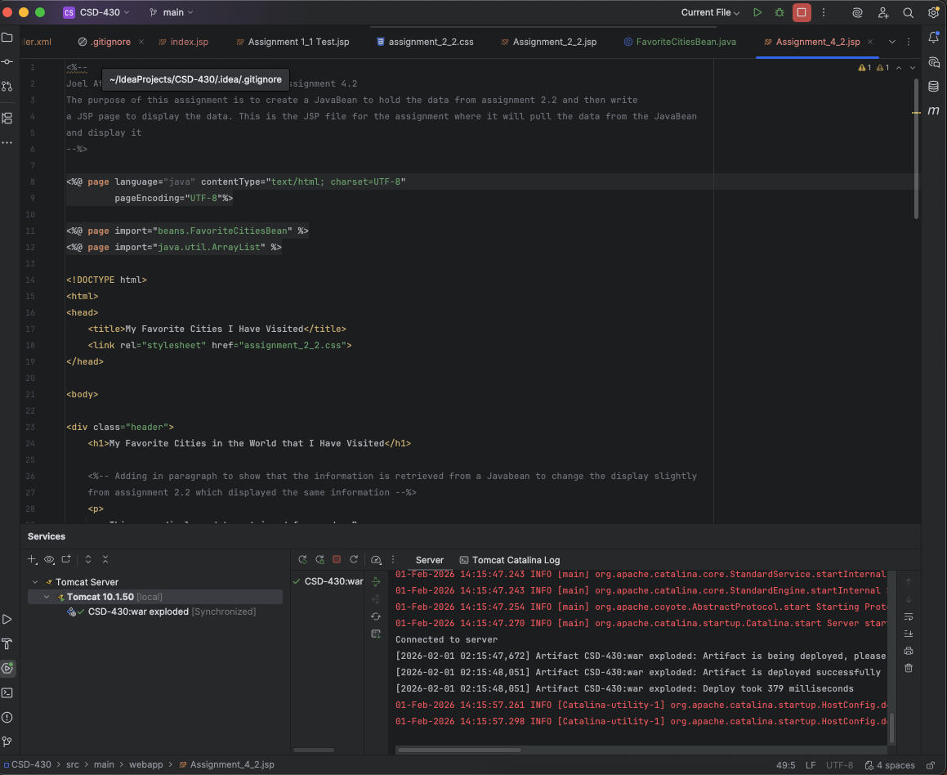

Screenshot of JavaBean file in IntelliJ with newly created “Beans” folder in SRC -> Main -> Java:
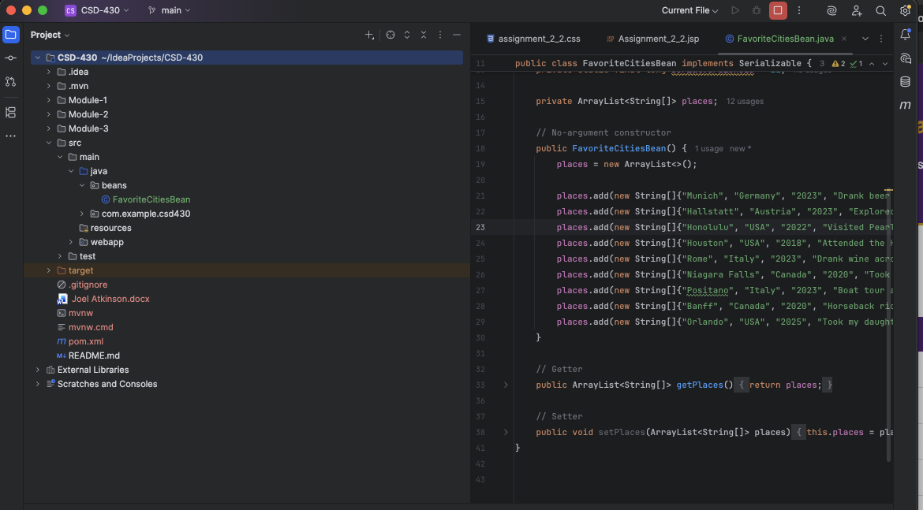

Screenshot of Web Page output:
